Group member names: Michael Eastman, Alexander Overley, Maurice Taylor, Mitchell Whyte, Dave Tobin, Narbada Acharya

**Exercise 6: Problem Solving** (10 points)

**Instructions:**

1. This is a group assignment. You only need to submit one solved exercise per group.
2. Provide your responses on this file, save it, and upload the file to the appropriate assignment response in blackboard.
3. You may upload as many attempts as you may like. Please note that only the most recent file uploaded file would be graded.
4. Do not handwrite any responses.
5. If you have any additional information you would like me to know about this assignment, you may provide that to me at the end of this document as a note.

**Use the INVOICE table structure provided below for this assignment:**

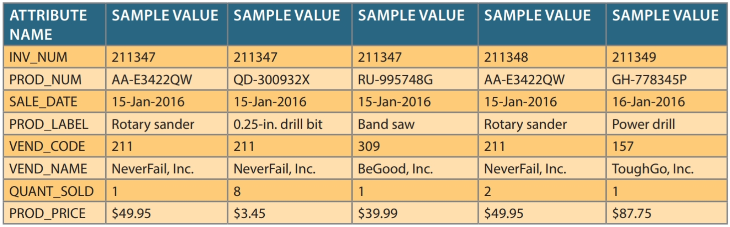

1. Write the relational schema, draw its dependency diagram, and identify all dependencies, including all partial and transitive dependencies. You can assume that the table does not contain repeating groups and that an invoice number references more than one product. (Hint: This table uses a composite primary key.) You can use the following schema as an example on how to present your response. You need to also note what type of dependency is it (i.e., partial or transitive). In your response, replace the example below with relational schema you would build in word.

**Relational schema: INVOICE (INV_NUM, PROD_NUM, SALE_DATE, PROD_LABEL, VEND_CODE, VEND_NAME, QUANT_SOLD, PROD_PRICE)**

Partial dependency

Partial dependency

INV_NUM

Transitive dependency

SALE_DATE

PROD_NUM

VEND_NAME

PROD_LABEL

VEND_CODE

QUANT_SOLD

PROD_PRICE

1. Remove all partial dependencies, write the relational schema, and draw the new dependency diagrams. Identify the normal forms for each table structure you created. You can assume that any given product is supplied by a single vendor, but a vendor can supply many products. Therefore, it is proper to conclude that the following dependency exists: PROD_NUM → PROD_LABEL, PROD_PRICE, VEND_CODE, VEND_NAME (Hint: Your actions should produce three dependency diagrams.) You can use the following relations as an example on how to provide your response. In your response, replace the example below with relational schema you would build in word.

**Table: Product**

**Primary Key: PROD_NUM**

VEND_CODE

VEND_NAME

PROD_PRICE

PROD_LABEL

PROD_NUM

**Foreign Key: None**

**Normal Form: 2NF**

**Table: Invoice**

**Primary Key: INV_NUM**

QUANT_SOLD

PROD_NUM

INV_NUM

**Foreign Key: PROD_NUM**

**Normal Form: 3NF**

**Table: Sale**

**Primary Key: INV_NUM**

SALE_DATE

INV_NUM

**Foreign Key: None**

**Normal Form: 3NF**

1. Remove all transitive dependencies (if any), write the relational schema, and draw the new dependency diagrams. Also identify the normal forms for each table structure you created.

**In order to remove all transitive dependencies, you must make VENDOR its own table as shown below.**

**Table: Product**

PROD_PRICE

PROD_LABEL

PROD_NUM

**Primary Key: PROD_NUM**

**Foreign Key: None**

**Form: 3NF**

**Table: Invoice**

**Primary Key: INV_NUM**

QUANT_SOLD

PROD_NUM

INV_NUM

**Foreign Key: PROD_NUM**

**Normal Form: 3NF**

**Table: Sale**

**Primary Key: INV_NUM**

SALE_DATE

INV_NUM

**Foreign Key: None**

**Normal Form: 3NF**

**Table: Vendor**

**Primary Key: VEND_CODE**

VEND_NAME

VEND_CODE

**Foreign Key: None**

**Normal Form: 3NF**